Linux Assignment

1. **Print screens and description of the steps that you have followed to have your Linux machine working**.

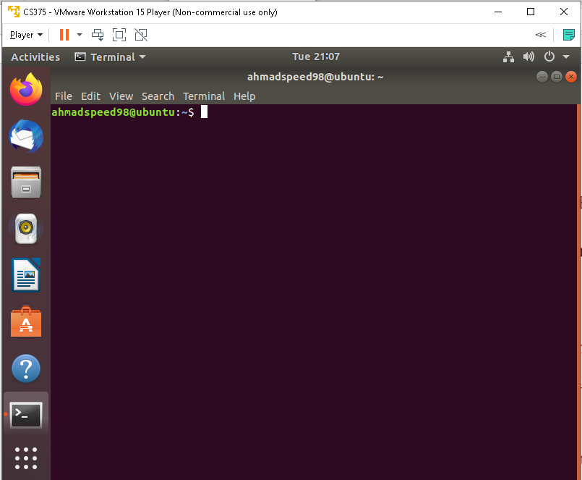

* Download VMware workstation player for windows
* Download Ubuntu
* Install VMware workstation player
* Run VMware workstation player on your machine.
* Click on create a new virtual machine.
* Click the Brows button and choose the Ubuntu iso press next.
* Type your information as required and then press Next.
* Use virtual machine name and choose where you want your virtual machine files to be stored press Next.
* Leave everything unchanged and press Next
* Leave everything unchanged again and press Finish.
* After some time installing, you will have a Linux running under VMpalyer.

1. **The problems that you faced during these steps and how did you solve these problems**

* I don’t face any problems

1. **Print screens and description (in your words) of the output of each command that you have run. Also talk about a situation in which you can use that command**.

**Command: ls**

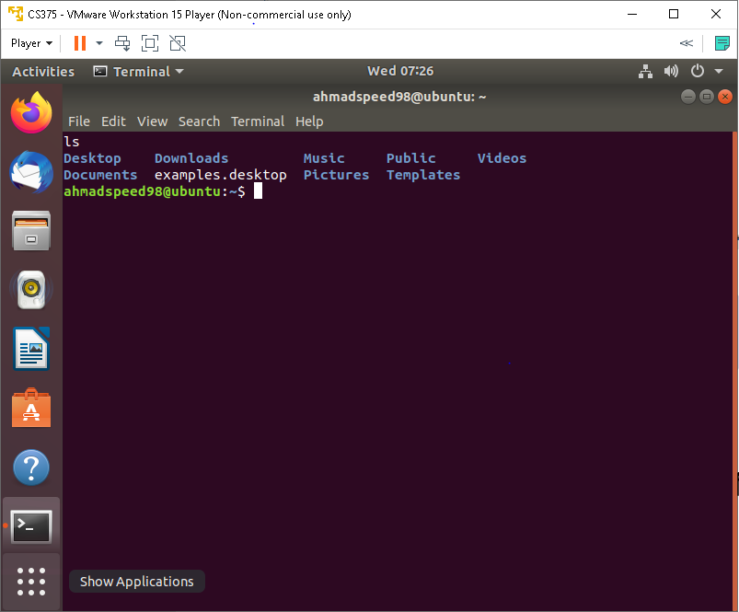

Here as we see those my directory and can list them by default alphabetical  order and can list them in to many way

**Command : ls -al**

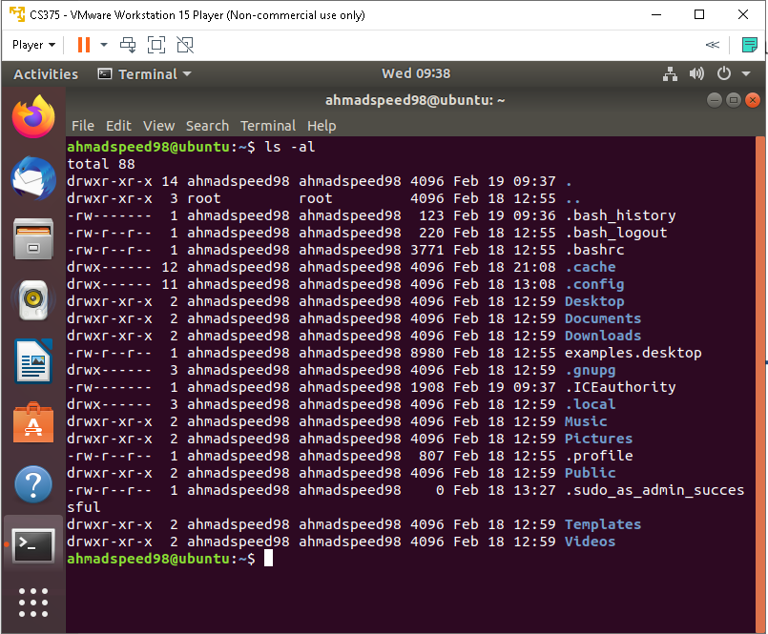

Show my hidden files in my directory (.)and use l when don’t know the list of them

**Command : pwd**

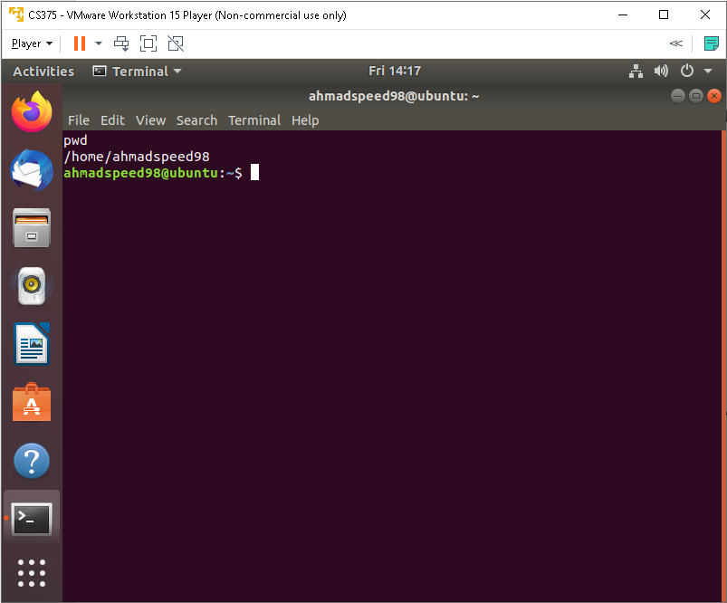

Used to know the current directory when we forgot where we are can use it

**Command : mkdir dir**

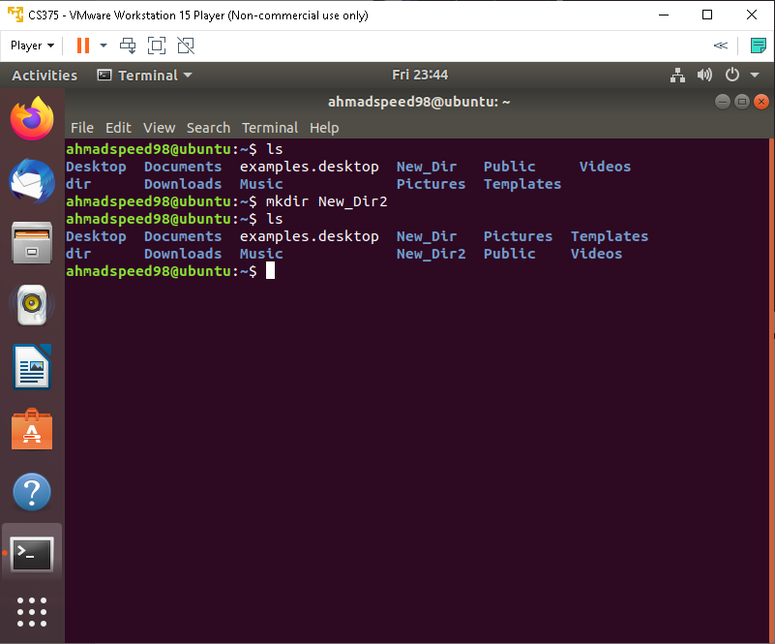

Create new directory can use it when filter file and put inside it files

**Command :cd dir**

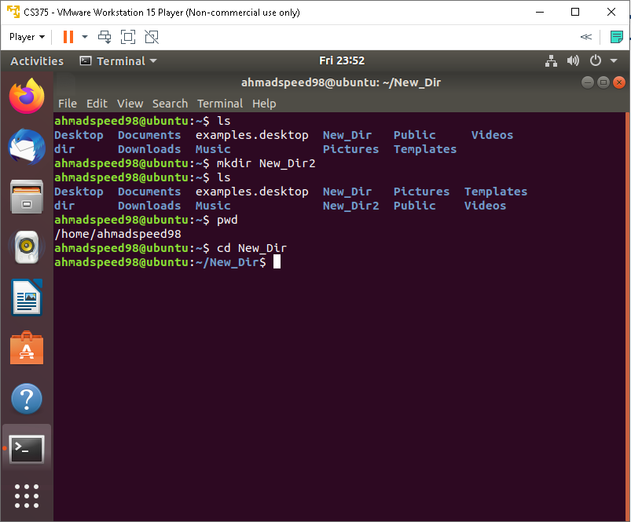

When we need to change the directory to new directory and jump from workplace to another

**Command :cd**

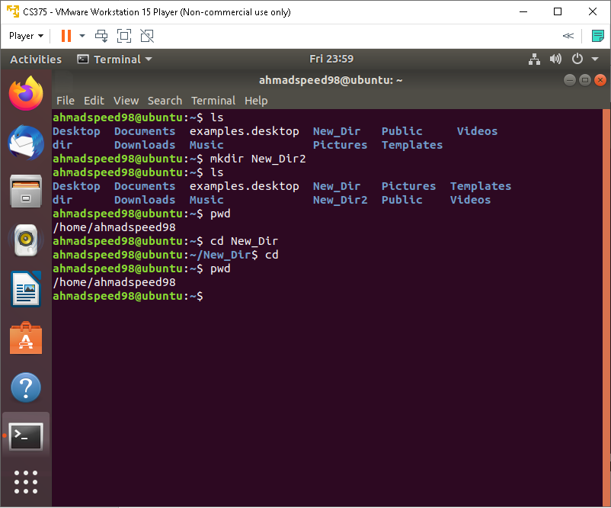

Here can go back from any directory to home directory

**Command: rm**

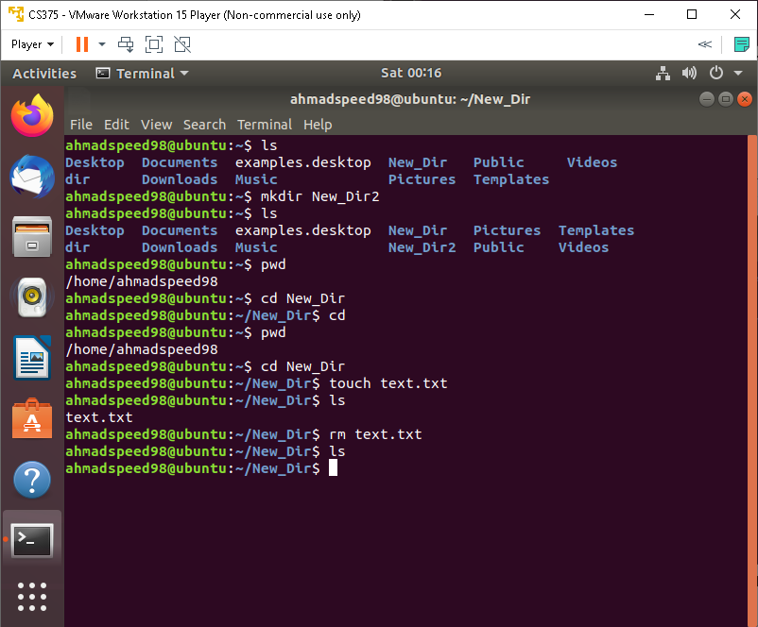

Here can delete files after been exist

**Command: rm -r**

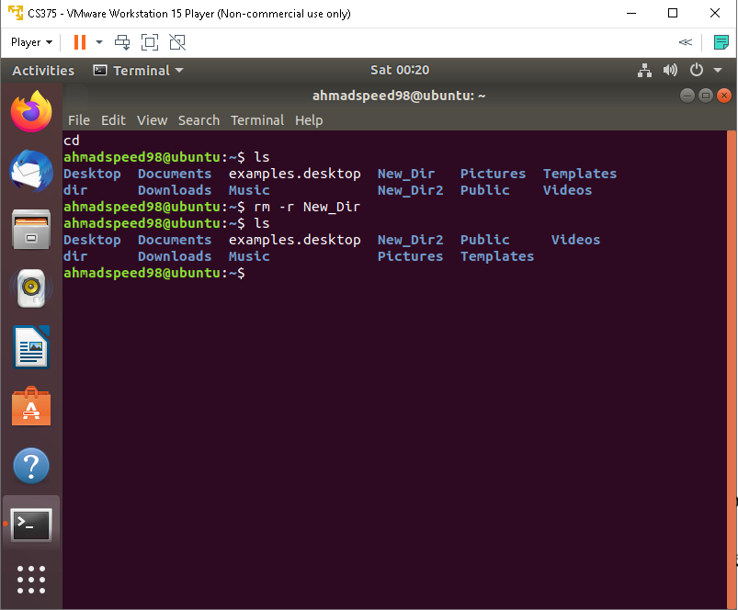

Here can delete the directory as all and the inside of it

**Command: rm -f**

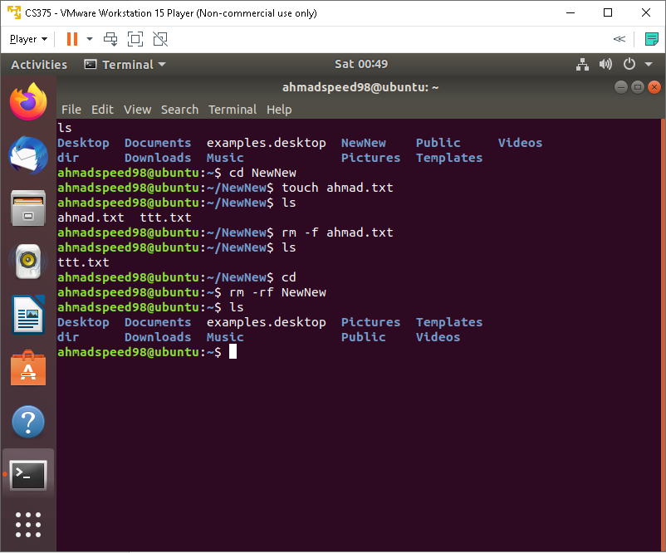

Delete file that should take permission to get deleted

**Command: rm -rf**



Delete dir that should take permission to get deleted

**Command: cp**

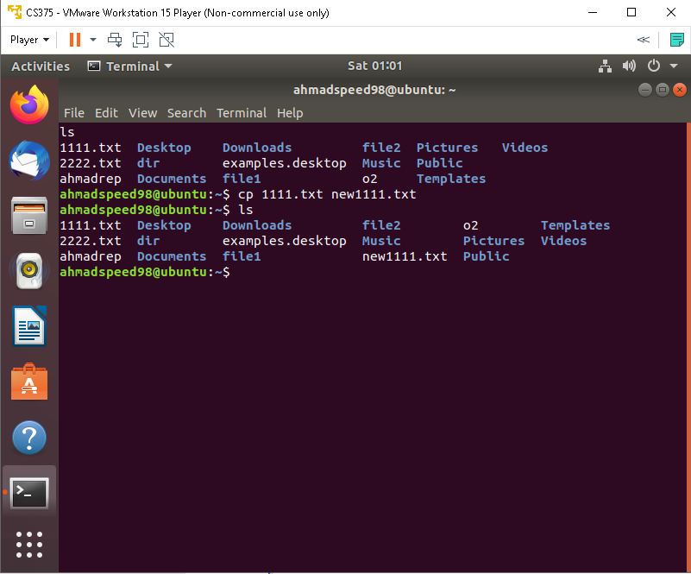

The contant of file1 copy to 2 or create it if don’t exist

**Command: cp-r**

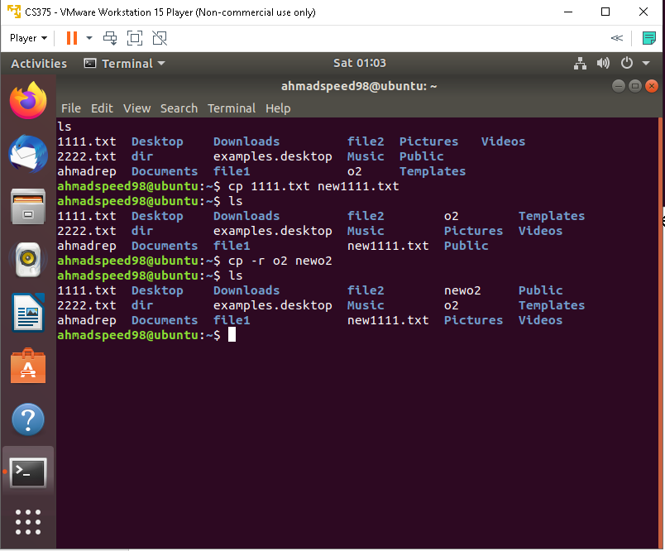

The content of dir1 copy to dir2 or create it if don’t exist

**Command: mv**

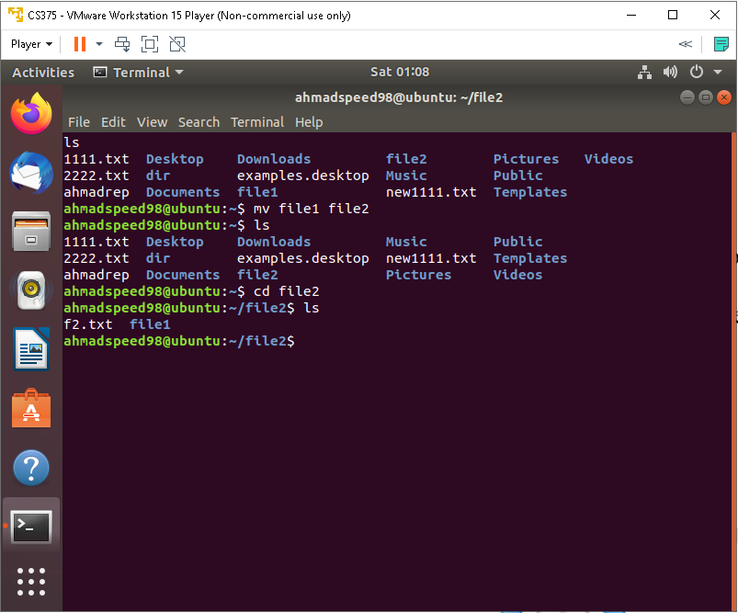

rename or move file1 to file2 if file2 is an existing directory, moves file1 into directory file2

**Command: cat >**

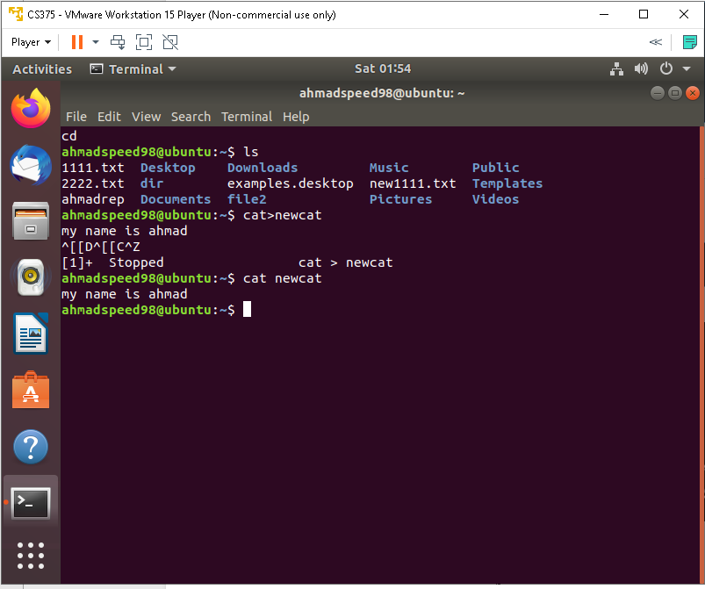

Create a file and set input inside it

**Command: cat**



can show the content of file that I create it

**Command: more**

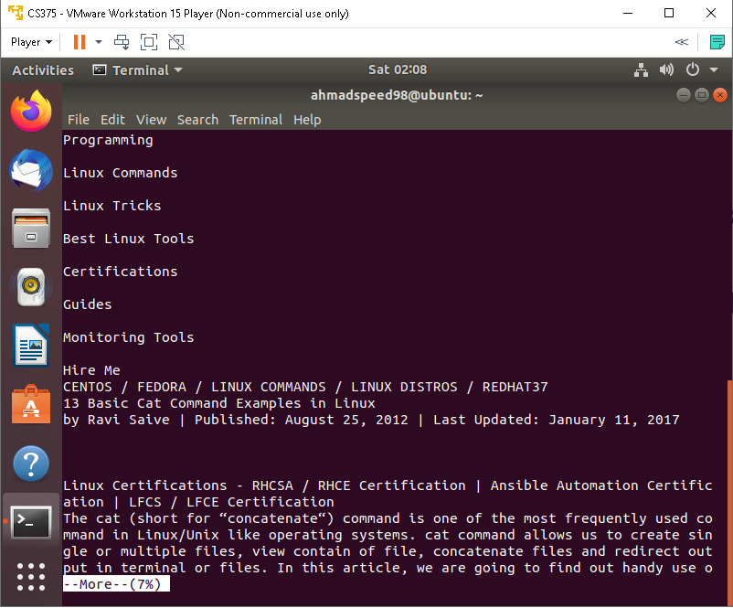

show the content on one screen and told us how % of data that we see

**Command: head**

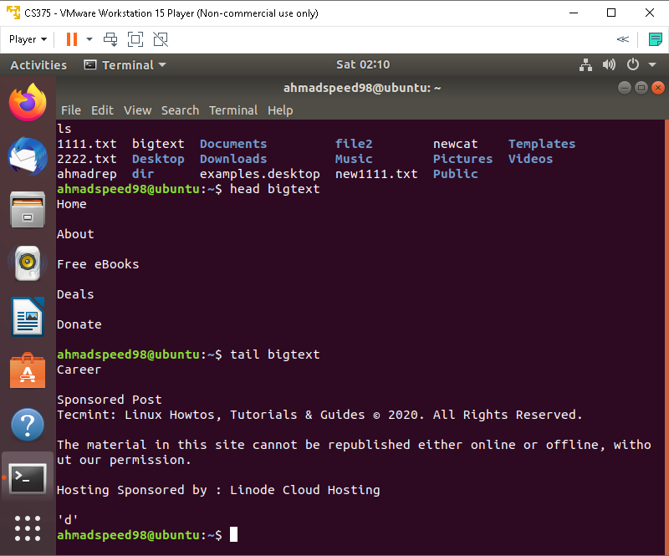

First 10 line

**Command: tail**



Last 10 line

**Command: date**

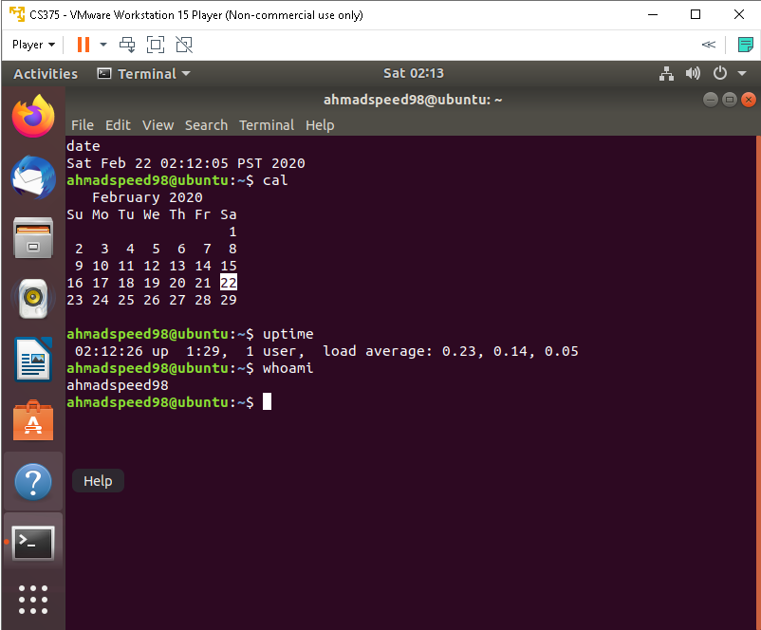

Show us the date in pst format

**Command: cal**



Show us the calendar and the current day

**Command: uptime**



how long your system has been running together with the **current time**, **number of users with running sessions**, and **the system load averages** for the past **1**, **5**, and **15** minutes. It can also filter the information displayed at once depending on your specified options.

**Command: whoami**



Show the current user

**Command: uname -a**

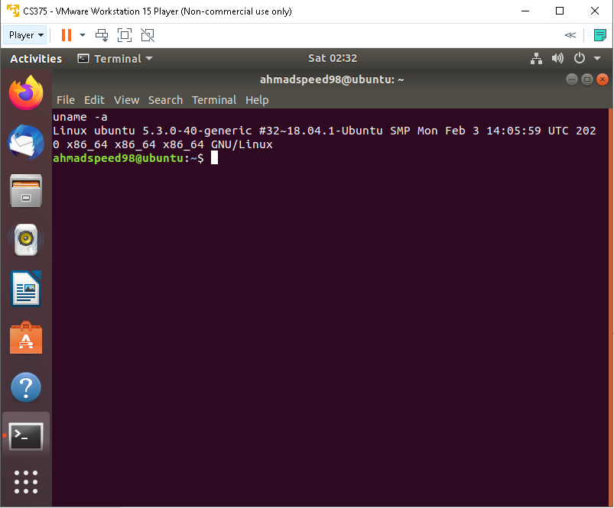

Show us the current version of kernel (linux)

**Command: cat /proc/cpuinfo**

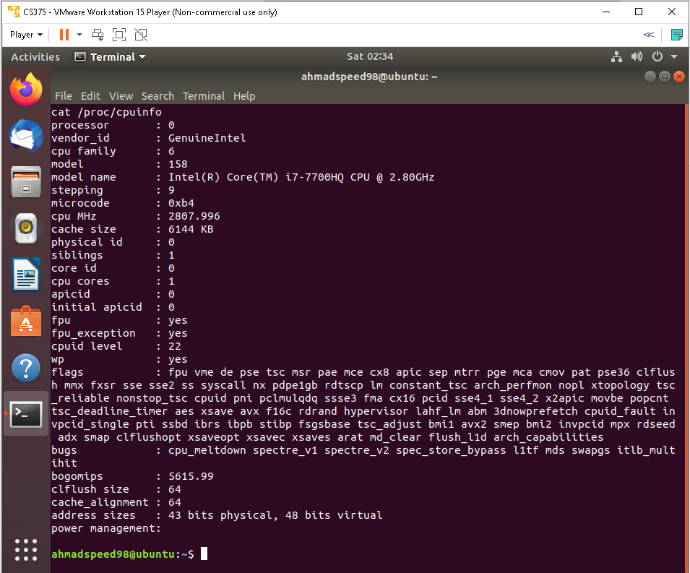

Show us the information of our cpu that running

**Command: cat /proc/meminfo**

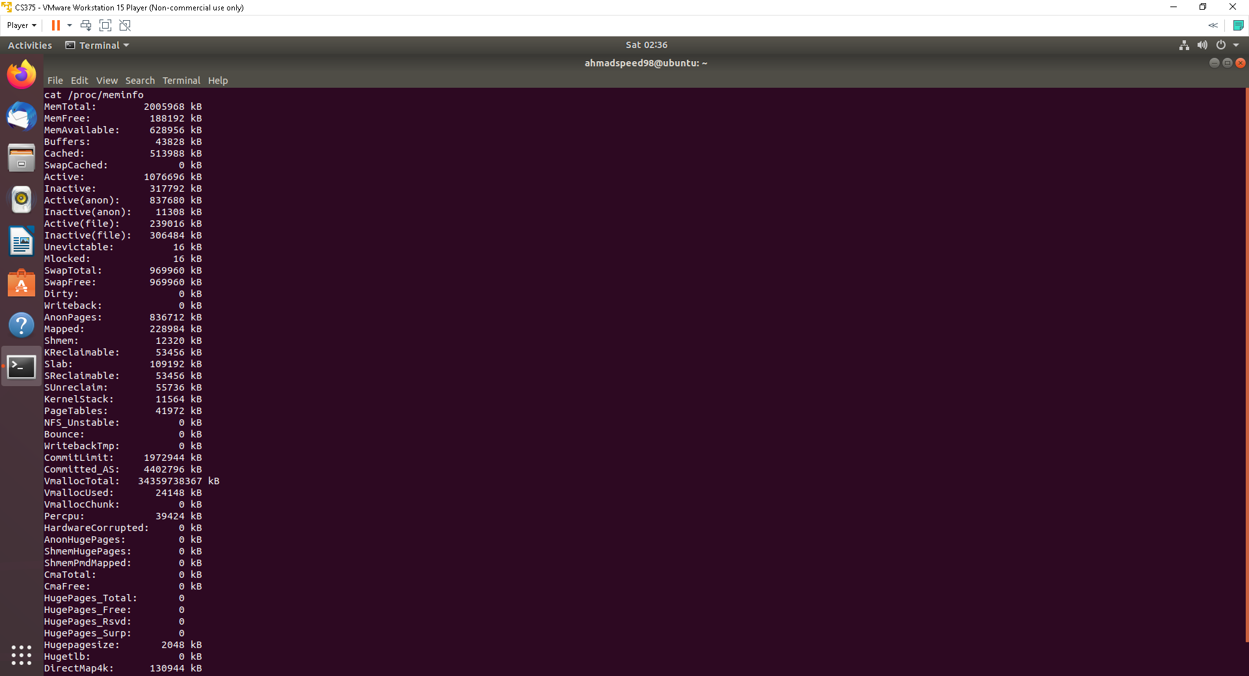

Show us the information of our memory that running

Command: cat /proc/meminfo

**Command: man**

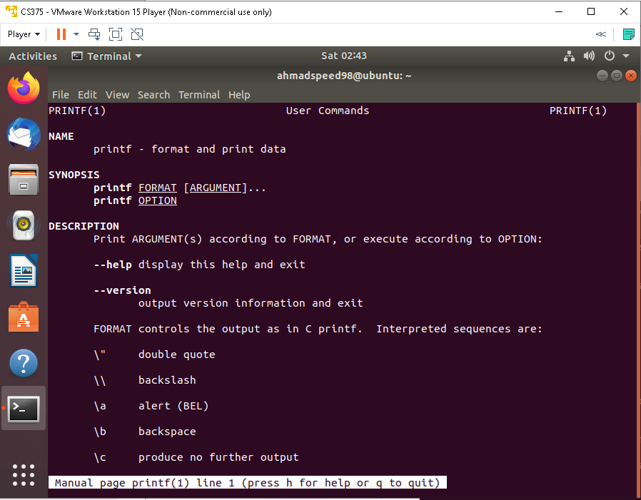

Show the Guideline of command that run on our terminal

**Command: df**

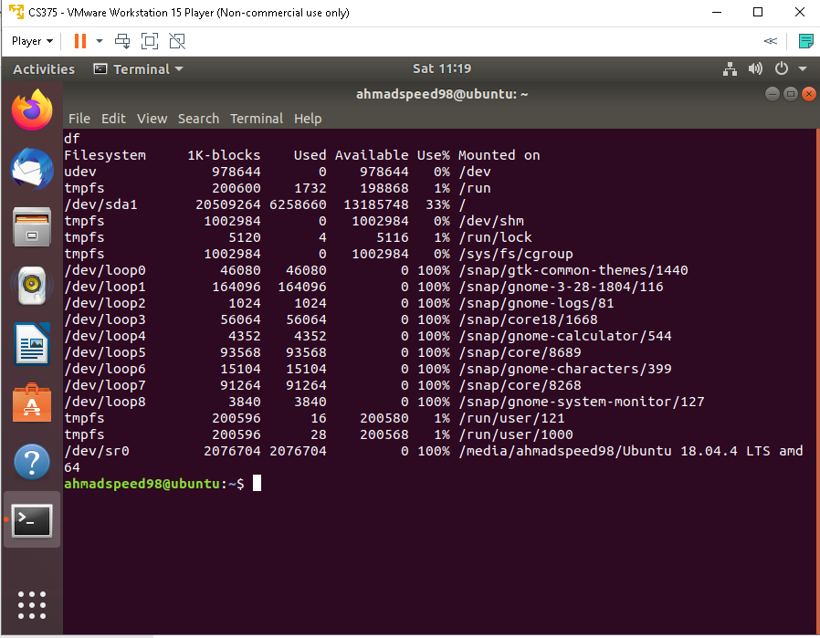

Show us the information of our disk usage

**Command: whereis**

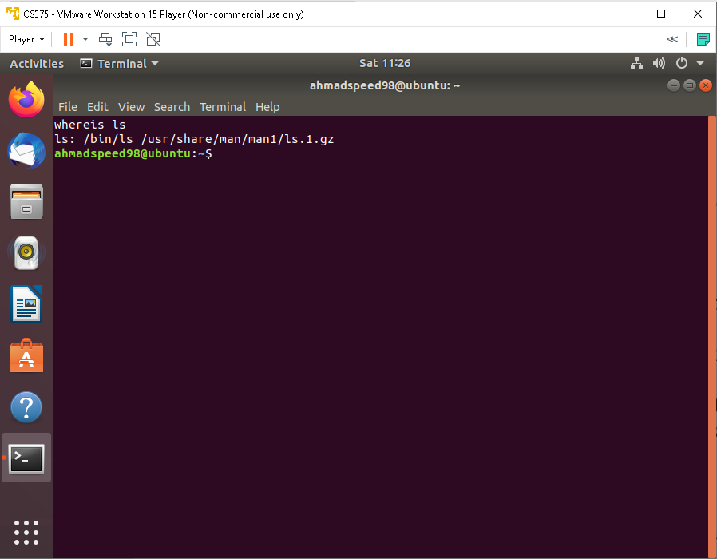

Search for the file after whereis and get the path

**Command: chmod**

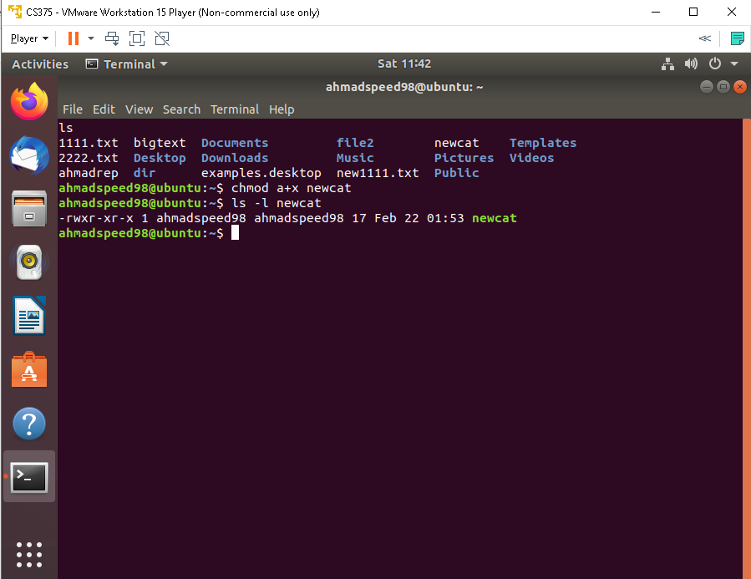

As we see the permission changed and used when we need the access to this file be controlled

**Command: grep**

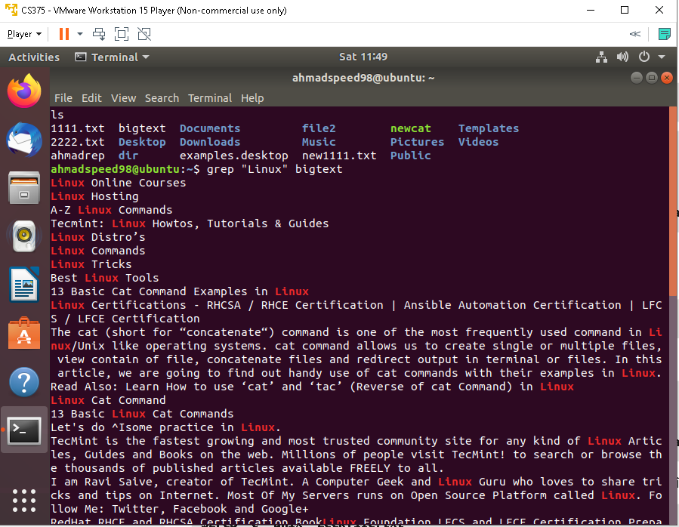

Show us the matches in the file we search on it

**Command: grep -r**

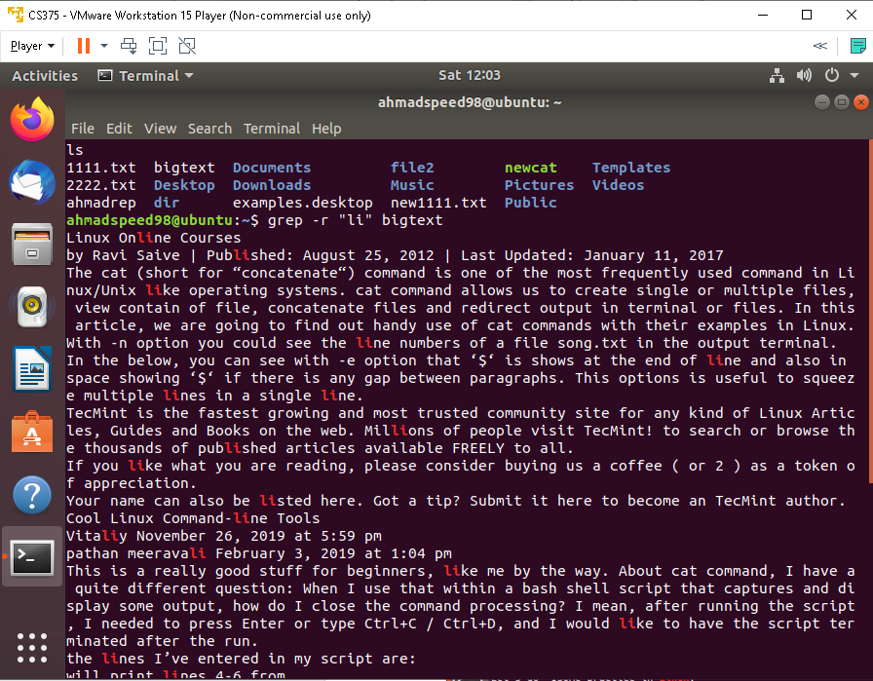

Recursive search

**Command: CTRL+C**

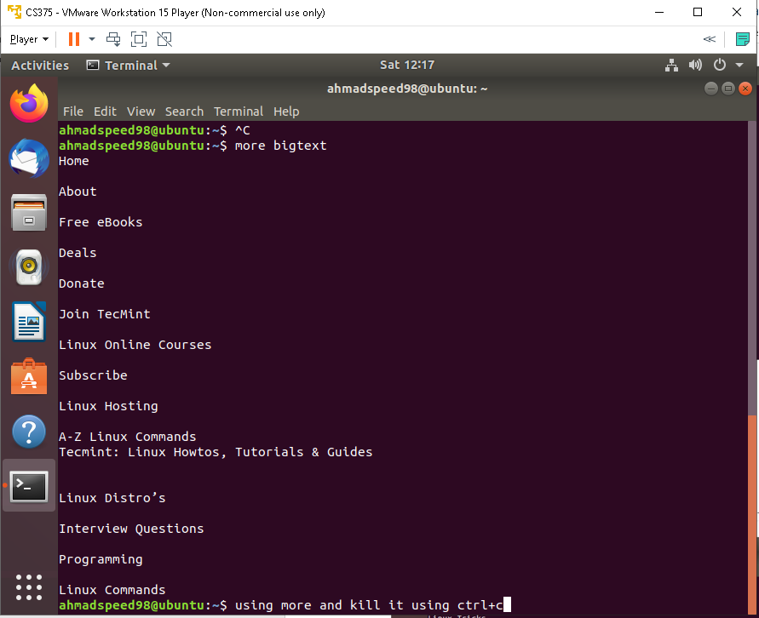

As we see we kill the more command while he running

**Command: exit**

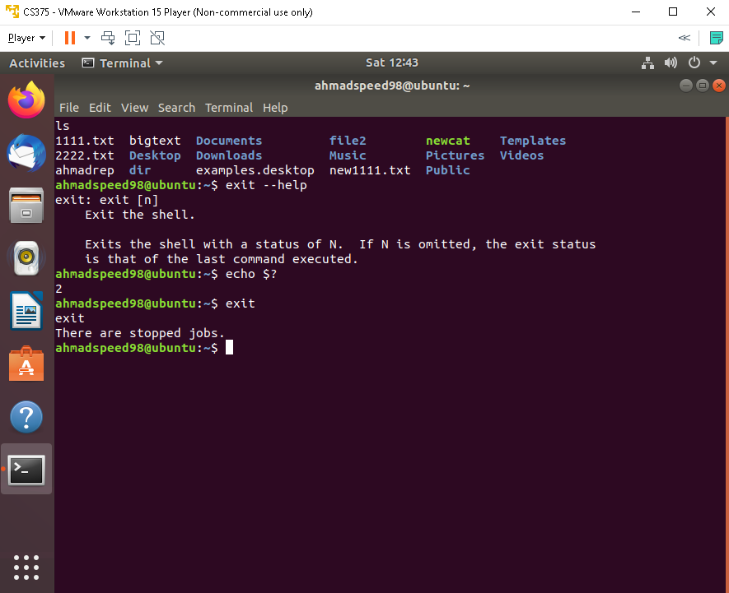

can give a specific value to get exit here by vm

and we use it to know and to exit the running